Board Input Output Information
- 2 – Pin header for Power input.
  - First pin (left) is GND
  - Second pin (right) is VIN (36VDC)
- The motor is rated at 36VDC / 1.2A current meaning we will need at least 36V / 2.5A Power Source
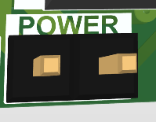
- 2 – Pin header for Pump output.
  - First pin (left) is VOUT (12V to power the pump)
  - Second pin (right) is GND
- The pump output is used for connecting an external pump to the board
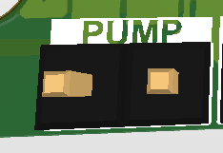
- 6 – Pin header for Motor output.
  - Pin 1 (leftmost) is Motor Coil A1
  - Pin 2 is Motor Coil A2
  - Pin 3 is Motor Coil B1
  - Pin 4 is Motor Coil B2
  - Pin 5 is OPEN (left open for connecting a 6-pin Stepper if needed)
  - Pin 6 (rightmost) is OPEN (left open for connecting a 6-pin Stepper if needed)
- The Motor Output is used for connecting the stepper motor to the board.
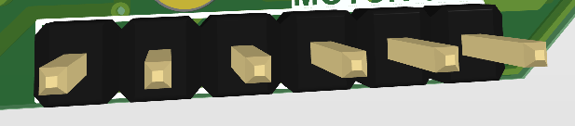
- 4 – Pin header (2X2) for Motor output.
  - Pin 1 is (bottom right) is VCC (5V).
  - Pin 2 is (bottom left) is UART (Receiver).
  - Pin 3 is (top right) is UART (Transmitter).
  - Pin 4 is (top left) is GND.
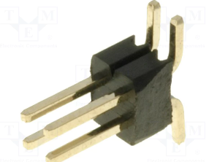
- 2 x RJ-45 Ethernet (EtherCAT) Connectors for Input/Output
